**Capstone Project Proposal Report**

**(Individual Report)**

**Instructions:**

This form is to be completed by each student doing Project registration to fulfill their senior design or capstone requirement. It must be completed and submitted to your Guide. Each student must complete this form individually.

This report is to be completed during the starting of the semester, while the project description report will be completed during end of the semester.

|  |  |  |
| --- | --- | --- |
| Guide Approval (initials/date): | Dr. Prabha Selvaraj | 13-06-21 |

**CAP4001– Capstone Project Proposal Report**

s

|  |  |  |  |  |
| --- | --- | --- | --- | --- |
| **Student Name** | | **Gaddam Sai Sheshank** | | |
| **Student Register Number** | | **17MIS7099** | | |
| **Programme** | | Mtech – Integrated Software Engineering | | |
| **Semester/Year** | | 9th Semester, 2021 | | |
| **Guide(s)** | | Dr. Prabha Selvaraj | | |
| **Project Title** | | Fire Recognition in Forests Using Deep Learning | | |
| **Team Composition:** Provide the information below for each member of the **project team**. Include **all** project team members, not just those in your discipline or those enrolled for Capstone project. Please also include yourself! | | | | |
| **Reg. No** | **Name** | | **Major** | **Specialization** |
| 17MIS7099 | G. Sai Sheshank | | Mtech Integrated | Software Engineering |

**Project and Task Description**:

1. **About Project**

Computer vision approach is one of the most powerful and extensively used techniques for real time applications such as traffic monitoring, facial identification, and surveillance systems, and has seen a spectacular increase in numerous technologies. Because of the fast increase in population, effective surveillance systems are in high demand to ensure security in densely populated areas. Fire detection and classification are intensively explored fields in computer vision and are used in a variety of applications such as surveillance systems, human-to-computer interactions, video retrieval, and so on. In the realm of computer vision, the recognition of various actions is a hot topic of research. The role of researchers has become more difficult as the demand for accurate action recognition has grown.

In everyday life, hand sign language is one of the frameworks that can recognize the

gesture of the hand in an ongoing video. The gesture of hand is ordered inside a specific Region

of Interest (ROI). Developing a deep learning system for Fire Recognition is one of the

objectives of accomplishing the targets of this proposed project.

1. **Methods Followed**

* The aim is to design an efficient system which can detect hand gesture for sign language using deep learning algorithms like CNN, ResNet.
* Later prune the best model out of all and proceed for model integration with Open CV.
* Then design a framework using computer vision technique called – Background Subtraction that is used to predict the hand gestures that is shown to the web camera and should display in the form of a text for the predicted letter.

1. **Design Process**:

Convolutional Neural Networks are a Deep Learning approach that we applied here (CNN). We chose this method because it effectively completes the task and also serves as a key component of a conventional Artificial Neural Network (ANN) with pre-processing. The Convolutional Neural Network (CNN) is a combination of Convolutional Layers and Neural Networks. Input layer, Convolutional Layer, Pooling Layer, and Dense Layer are the layers that make up any Neural Network used for image processing

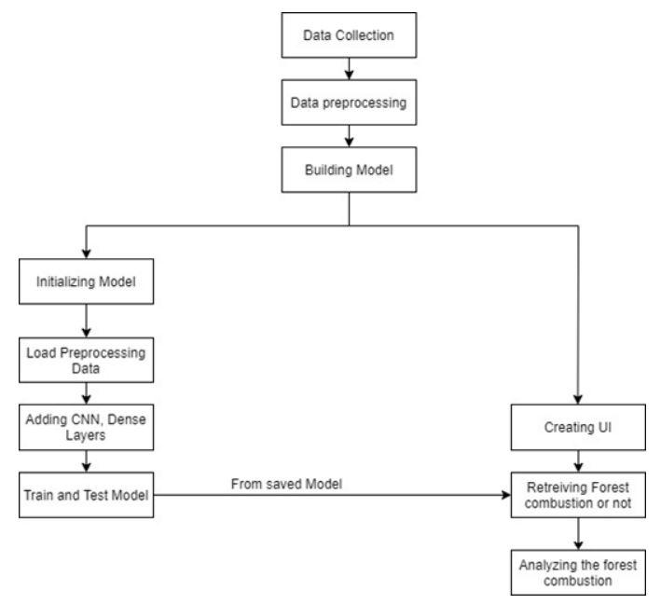

1. **Gantt Chart**

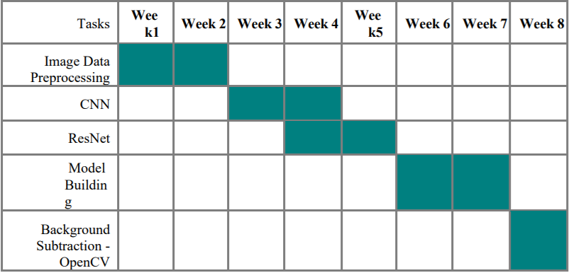

**Outcome Matrix:** Describe your plan to demonstrate each of the outcomes below.

|  |  |
| --- | --- |
| **Outcomes:** | **Plan for demonstrating outcome:** |
| a) an ability to apply knowledge of mathematics, science, and engineering | All of the deep learning algorithms implemented are based on statistical and  mathematical concepts. |
| c) an ability to design a system, component, or process to meet desired needs within realistic constraints such as economic, environmental, social, political, ethical, health and safety, manufacturability, and sustainability | The code that is going to implement can be run on any OS/platform that  supports Python as long as the input is in an image format at anytime and  anywhere. The final output can be used to identify the fires and smokes caught in the forests. |
| d) an ability to function on multidisciplinary teams | Can be used by anyone who predict whether the forests caught fire or not. |
| e) an ability to identify, formulate, and solve engineering problems | Aimed at helping people to protect forests lives and Greenery of the world |
| g) an ability to communicate effectively | The code and report carries relevant information that is fairly easy to read and  understand. Further explanation via a presentation would help. |
| k) an ability to use the techniques, skills, and modern engineering tools necessary for engineering practice | Using python, Deep learning algorithms and Jupyter notebook (Anaconda), a  solution to a real-time necessary issue for forest combustions was created. |

**Realistic Constraints:**

* Dataset was limited to only 0 & 255 pixels (i.e., black & white).
* The algorithms used all are image classifications.
* The final output using Open CV shouldn’t contain any background noise such as shadow or non-plain.

**Engineering Standards:**

ISO/IEC 9126 - under this standard, the following quality attributes have been

followed for thisproject:

* Efficiency- The model must run efficiently without consuming much time.
* Reliability - The model should be able to predict accurately.
* Availability - The model is available till the system on which it is installed.
* Maintainability - is platform independent, can run on any platform that supports python.
* Portability - can be used by anyone anywhere as long as they have access to a platform to run the python code.